Session 7
Reading candlestick charts
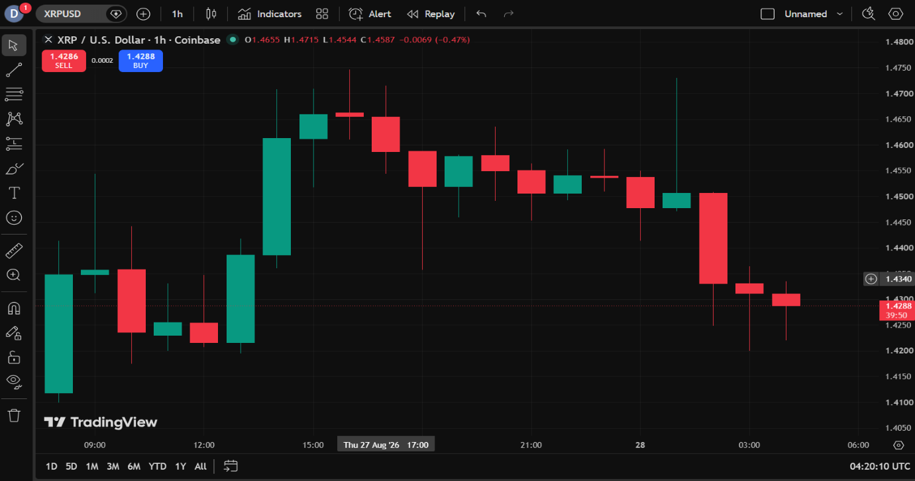
Candlestick Observation Report:
PARTICULARS | OBSERVATION
ASSET | XRP
SYMBOL | XRPUSD
TIME FRAME | 1Hour
NUMBER OF GREEN CANDLES OBSERVED | 8
NUMBER OF RED CANDLES OBSERVED | 12
DOJI OBSERVED | NOT OBSERVED
HAMMER OBSERVED | NOT OBSERVED
SHOOTING STAR OBSERVED | NOT OBSERVED

Session 8
Trend Observation Report
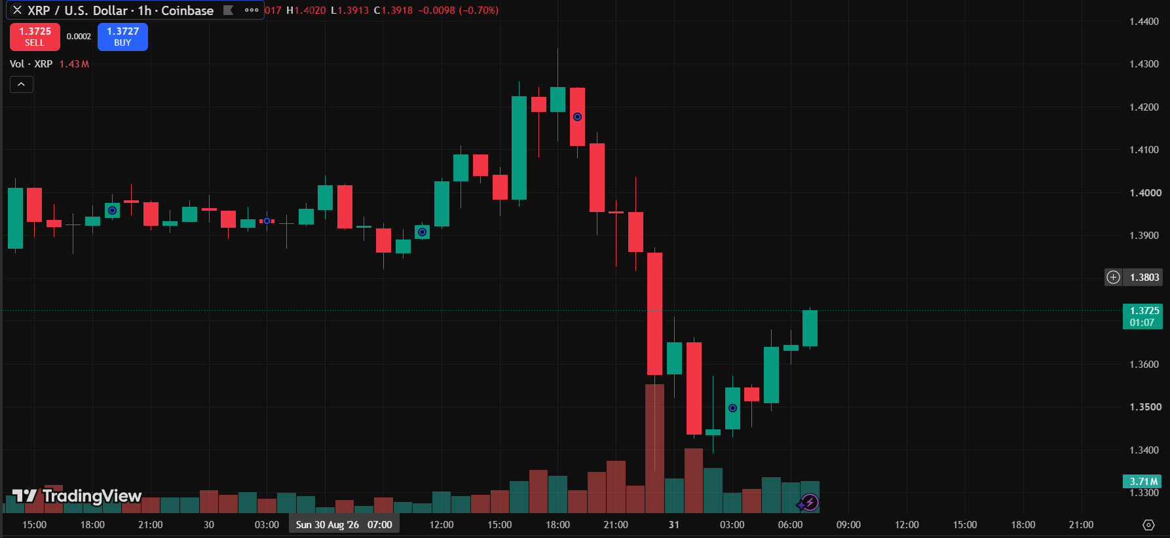
Particular | Observation
Asset Name | XRP
Symbol | XRPUSD
Timeframe | 1 Hour(1h)
Trend Observed | Downtrend
Number of Candlesticks Observed | 40
Reason for Identifying the Trend | The chart shows a series of lower highs and lower lows,indicating an Downtrend

Session 9
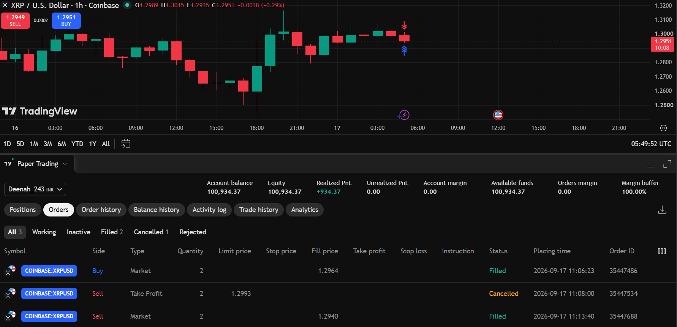
Trend-Based Trade Report.

Particular | Observation
Asset Name | XRP
Symbol | XRPUSD
Timeframe | 1 Hour (1H)
Trend Observed | Uptrend
Trade Type | Long (buy)
Entry Price | 1.4257
Exit Price | 1.296
Realized Profit/Loss | −0.46INR
Trade Outcome | Loss
Reason for Identifying the Trend | The price showed a series of higher highs and higher lows, indicating an upward trend.  Hence, a Long (Buy) trade was taken based on the bullish price movement.

